
BATCH NO:

Cyberbullying Prediction Using Machine Learning
Abstract:

- Communication through internet is shifting towards user friendly technologies such as social networking applications, blogs, online sharing platforms, etc.
- ´The misuse of such technologies leads to cybercrime which includes phishing, malware spreading, spam distribution and cyberbullying.
- ´Cyberbullying is an ethical issue found on internet and the percentage of the victims is also alarming.
- This project offers a comprehensive understanding of Cyberbullying incidents and their corresponding offences combining a series of approaches reported in relevant Work.
- The implementation provides the opportunity to systematically combine various element or Cyberbullying characteristics. Additionally, a comprehensive list of Cyberbullying-related offences is put forward.
- The offences are ordered in a Deep Neural Network classification system based on specific criteria to assist in better classification and correlation of their respective incidents.
- This enables a thorough understanding of the repeating and underlying criminal activities.

Batch Members:
S. No | Roll No | Name of the Student | Contact Number | Mail ID
1
2
3
4

Name of the Guide:

Guide Project Coordinator HOD

Project work flow diagram
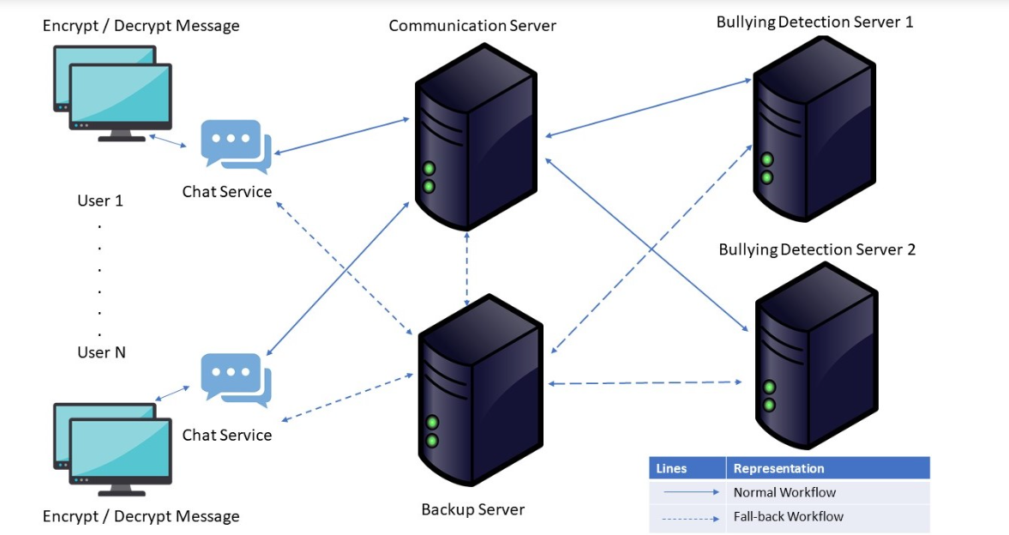

Existing system
- ´Many works in this field have shown that machine algorithms can be used for predicting and detecting cyberbullying actions.
- ´It consists of comparison between various algorithms like SVM(SupportVectorMachine),NB(naiveBayes),RF(randomforest),DT(decisiontree),CNN(Convolitional),LR(logisticregression),ARM(association-rule-mining),RB(rule based algorithm).
- ´Out of all this the CNN algorithm is the best based on factors like accuracy, precision recall .
- ´The limitation of this existing system is the unexplored deep learning architecture

DISADVANTAGES
- Lack of a concise classification and monitoring of the particular offences it entails.
- It faces the problem of over and under sampling, this affects the accuracy.
- The multiple interpretations of what Cyberbullying entails along with nonsystematic classification of the corresponding offences and lack of recommended actions are not contributing toward managing and orchestrating effective directives and result in ineffective handling of Cyberbullying incidents.

Proposed system
- This project aims to contribute toward better understanding Cyberbullying by proposing a schema-based Cyberbullying incident description that:
- ´1) identifies the feature s of a Cyberbullying incident and their potential elements and
- ´2) provides a DNN Based offence classification system based on specific criteria.
- ´The proposed schema can be extended with a list of recommended actions, corresponding measures and effective policies that counteract the offence type and subsequently the particular incident.
- ´This matching will enable better monitoring, handling, and moderating the various Cyberbullying offences and their incarnation in the form of specific incidents.

Advantages of proposed system in project
- ´For Cyberbullying offences with high frequency of occurrences this can prove quite helpful as a guide.
- ´By identifying the elements of each feature we can then further examine any interrelations between specific elements that would highlight specific aspects of Cyberbullying offences.
- ´Involves the detection of the exact threat that caused the offence
- ´The severity labeling of offences aims to formally assess the threat for prevention, evaluation and gathering of Cyberbullying statistics after crime commitment

